AegisLife Insurance
Risk Analytics and Claim Intelligence
1600+ customers, 2800+ Policies, 1400+ claims analyzed Using Excel and MySQL

Overview:
AegisLife is an insurance company selling five product lines Health, Property, Term, Vehicle, and Whole through a network of agents across multiple regions, but the company lacks a consolidated view connecting who its customers are, how they behave, and where the business is losing money. Customer risk profiles, policy sales, lapses, claims, fraud incidents, agent performance, and customer satisfaction currently sit in disconnected records, making it difficult to answer basic questions like which region and product have the highest policy lapse rates? Are fraudulent claims concentrated in specific risk segment? Without this consolidated analysis, retention, and fraud-control decisions are being made on incomplete information.

Project Flow:
- Data Collection:
Five raw datasets were sourced covering customers (1648), agents (300), policies (2828), claims (1406), and feedback surveys (631).

- Data Cleaning:
Before loading data into the database, the raw CSVs were cleaned and standardized in Excel.

- Database Design (DDL):
MySQL schema (aegislife_risk_analytics) was designed with the five tables – customer_master, agent_info, policy_details, claim_history, customer_feedback_surveys.

- Data Ingestion:
Cleaned CSVs were loaded into the schema using LOAD DATA INFILE.

- Exploratory & Diagnostic Analysis (SQL):
Structured SQL analysis was carried out across eight business areas: Customers and Acquisition, Risk Analysis, Policy & Sales, Retention/Lapses, Claims, Agent Performance.

Data Cleaning:
Before the data loaded into SQL database, all five tables were checked for usual real-world issues and fixed accordingly.

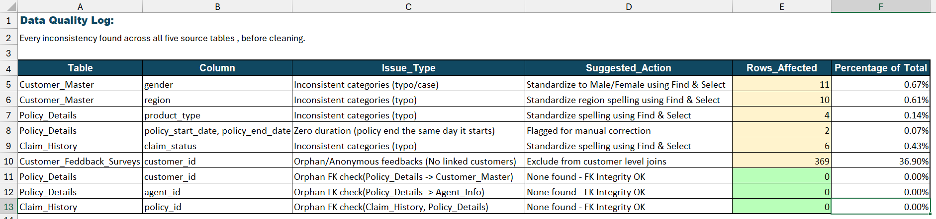

The workbook Data_Quality_Log keeps the full before/after for all 5 tables specifically for customer_feedback_surveys, since that’s the one tale where cleaning changes the row count: 1000 raw responses go in, 369 rows were flagged orphan as no customer data was available against those customer ids and 631 valid responses comes out. The other four tables show their validated state.

Database Design & Data Ingestion:
First the database aegislife_risk_analytics is created in MySQL, and then all five tables created using SQL DDL with primary keys, foreign keys, and other constraints.

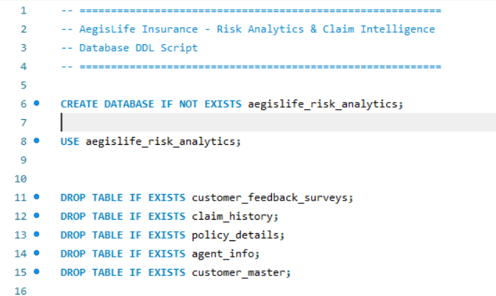

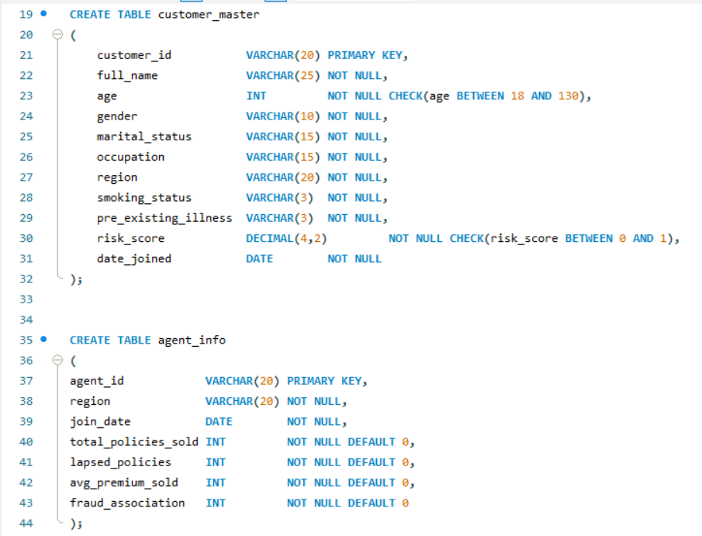

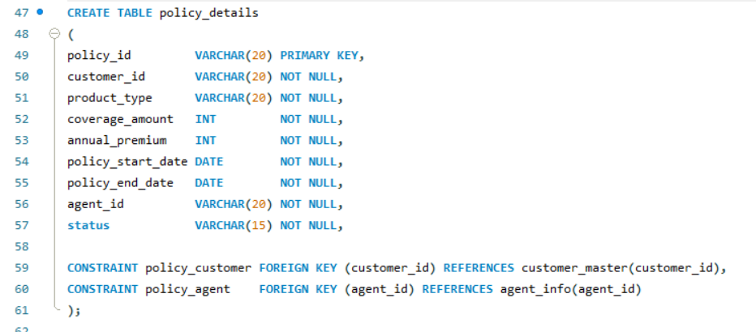

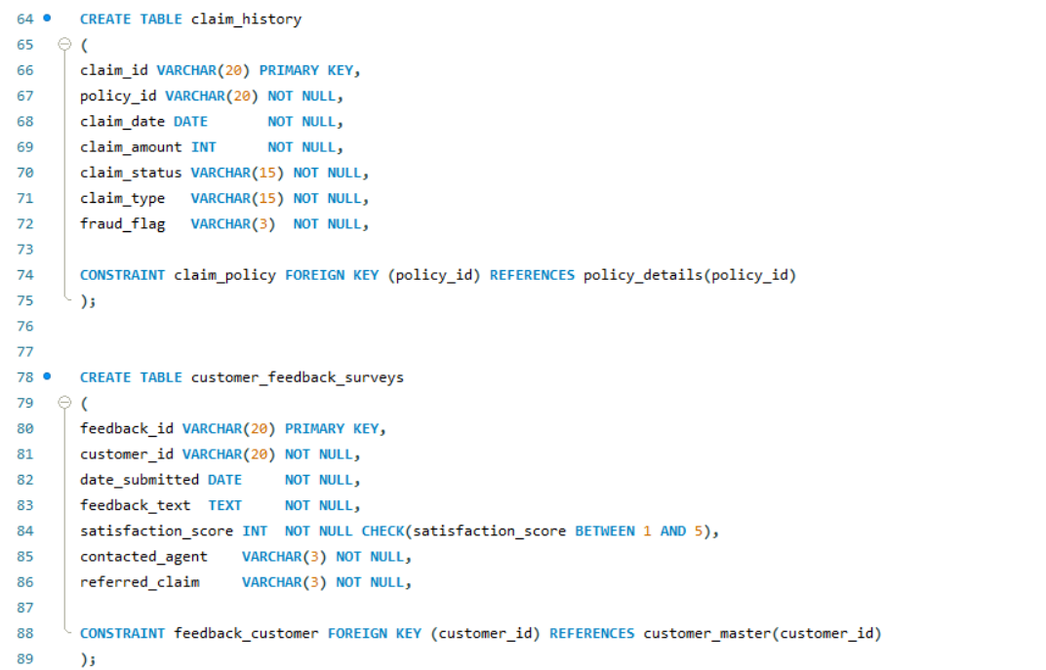

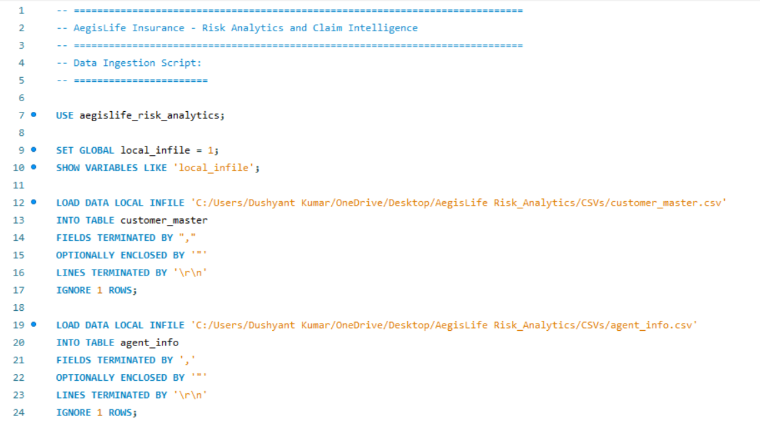
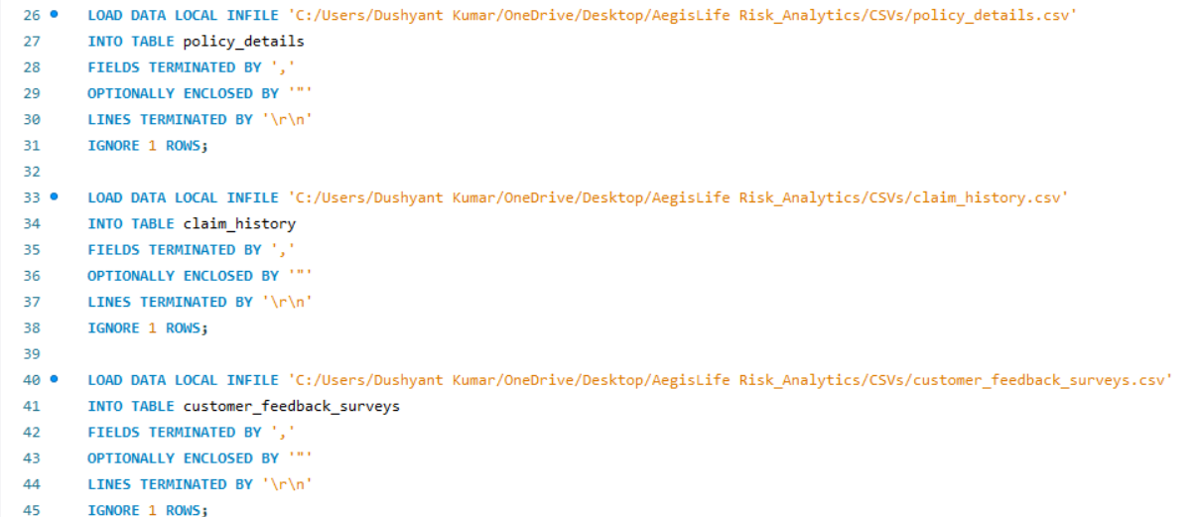

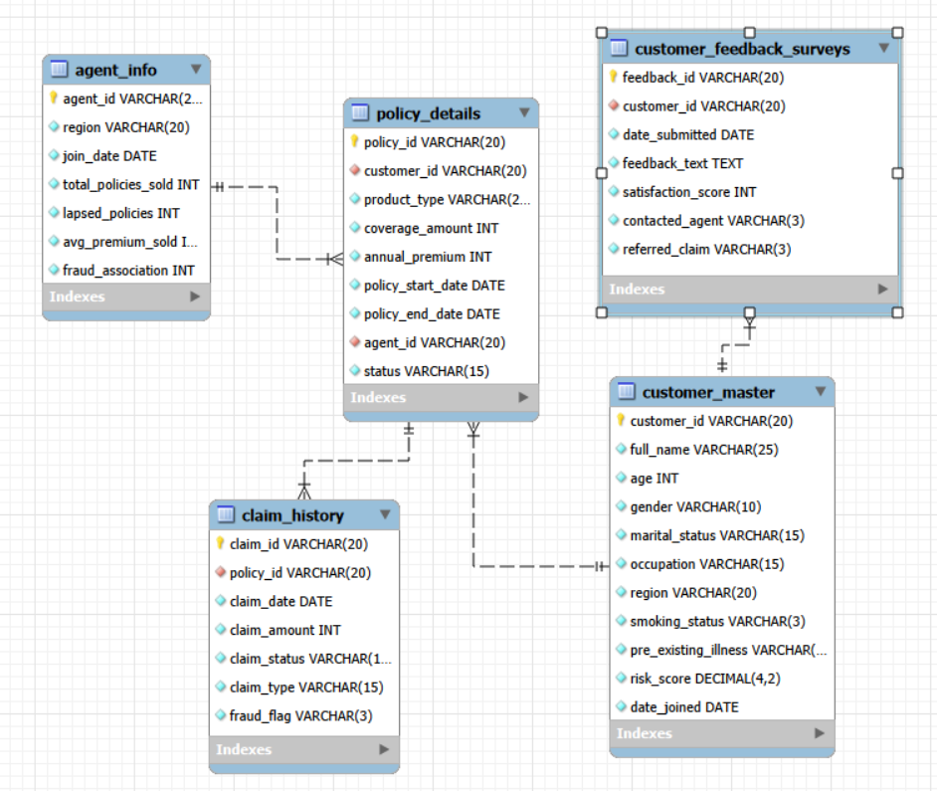
Exploratory & Diagnostic Analysis (SQL):
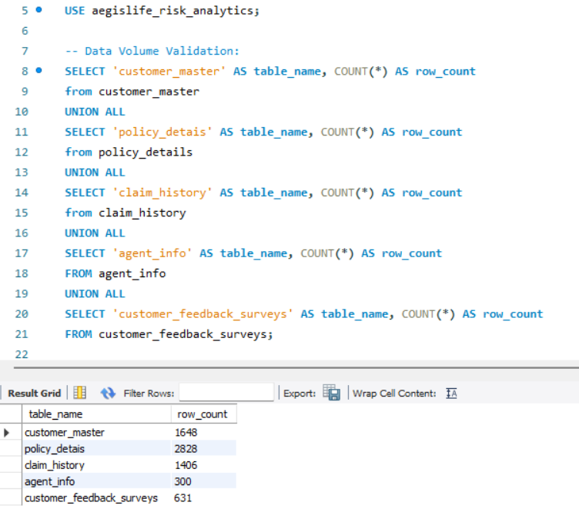

Performed a data-volume validation after ingestion to confirm that all source tables were loaded. This validation provides an initial check that the ingestion process completed successfully and gives a clear view of the data available for analysis.

CUSTOMER & ACQUISITION ANALYSIS:

- Total customers in AegisLife:
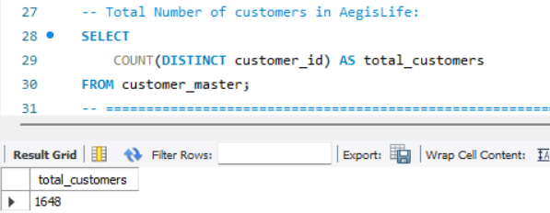

There is total 1,648 customers with AegisLife.

- How is the customer base distributed across regions?
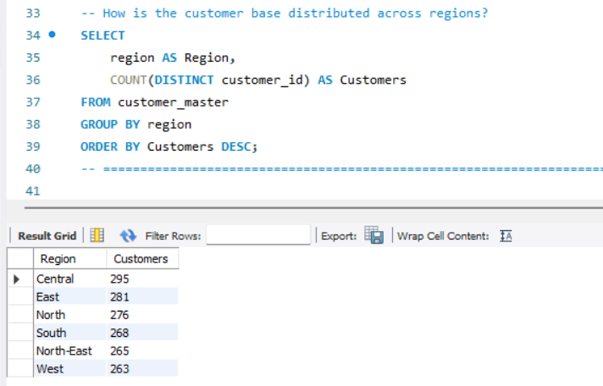

The geographical distribution shows a relatively balanced distribution. AegisLife have a relative spread across the country.

- How is the customer base distributed across various age-groups?
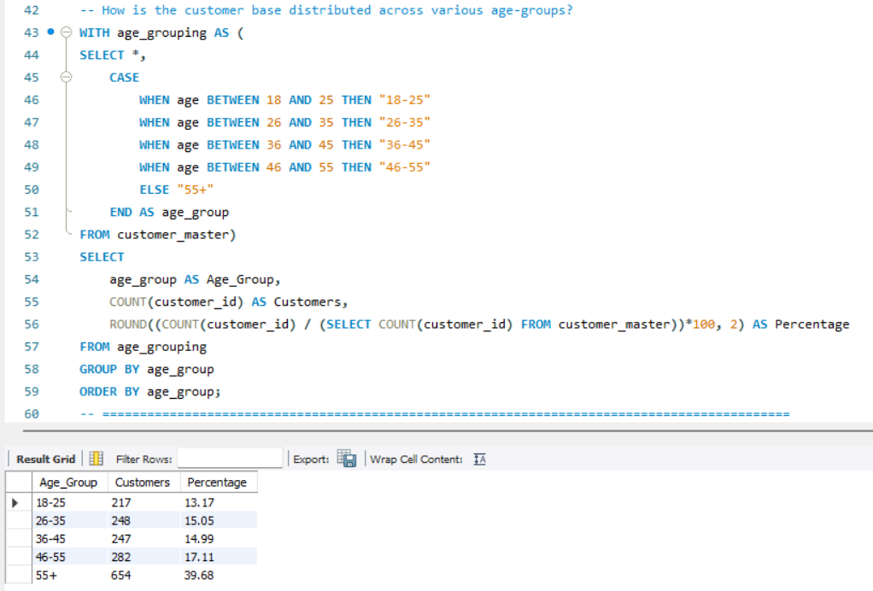
The customer base is heavily concentrated among older age groups. Customers aged 55+ represent the largest segment, with 654 customers (39.68%).
- How the customer base distributed across occupation?
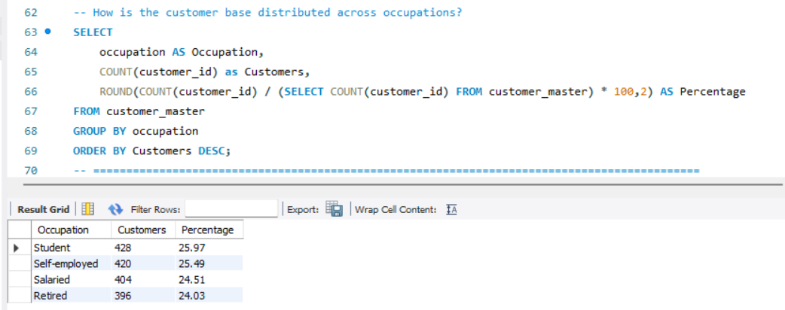
The customer base is relatively evenly distributed across four occupational groups.

- How has customer acquisition changed year-over-year?
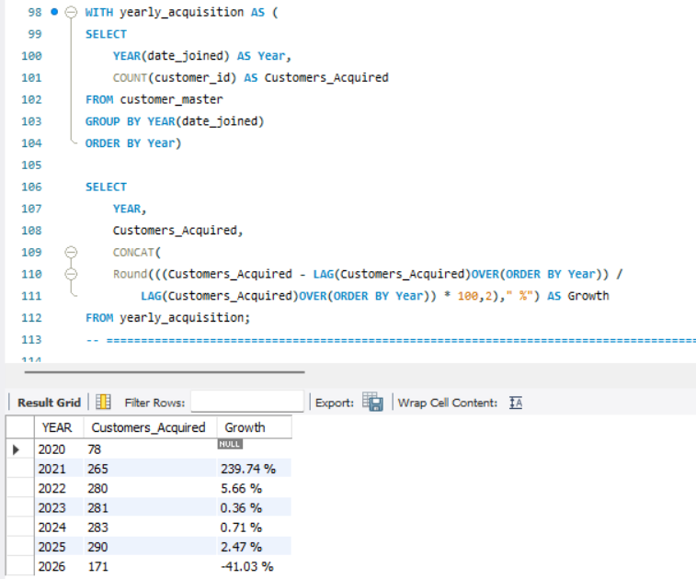
Customer acquisition increased dramatically between 2020 and 2021, rising from 78 customers to 265, representing a 239.74% Year-over-Year increase. This was followed by continued but much slower growth in the subsequent years.
CUSTOMER RISK ANALYSIS:
- What is the overall average customer risk-score?
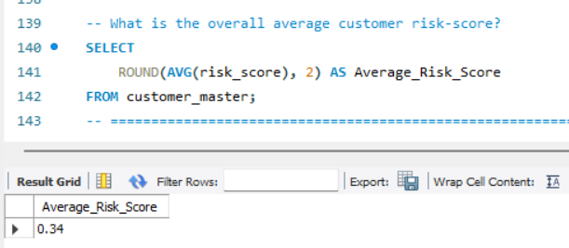
The average customer risk-score is 0.34, indicating that the average risk score across the customer base is relatively low.

- Which age-group has the highest average risk-score?
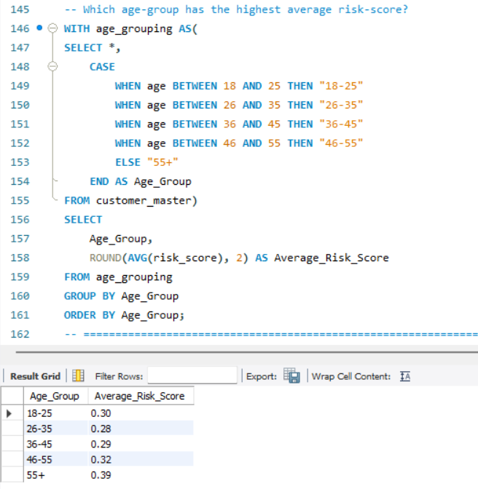
The average risk-score increases with age, with the 55+ customer segment having the highest average risk score of 0.39. This result show that older customer segment have higher average risk-score in the dataset.
- Do smokers have higher risk-score than non-smokers?
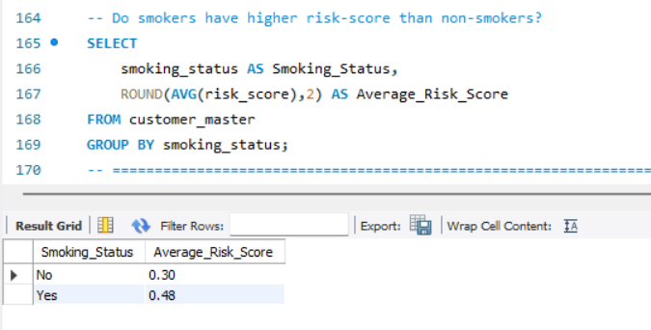
Customers with smoking status as “Yes” have a substantially higher average risk-score than non-smokers.

- Do customers with pre-existing illness have higher risk-score?
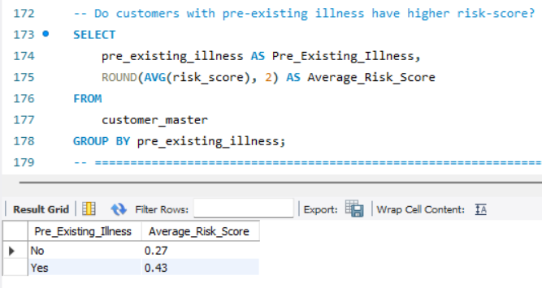
Customers with pre-existing illness have a substantially higher average risk-score than customers without pre-existing illness.

Does higher customer risk-score translate into higher premiums?
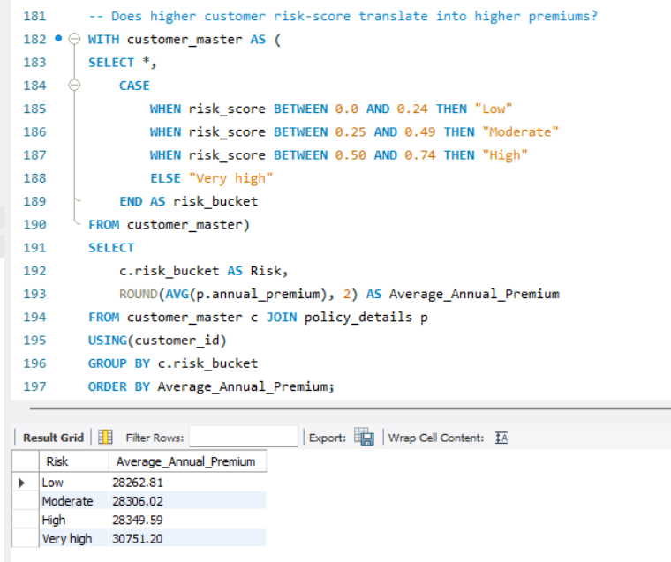
Average annual premium generally increases as customer risk increases, although the difference is relatively small between the Low, Moderate, and High-Risk segments.

POLICY & SALES ANALYSIS:
- Total policies sold by AegisLife.
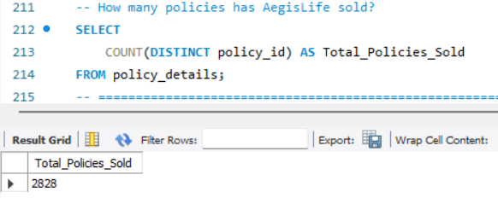
AegisLife has sold a total of 2.828 policies.

- What percentage of customers have no policy?
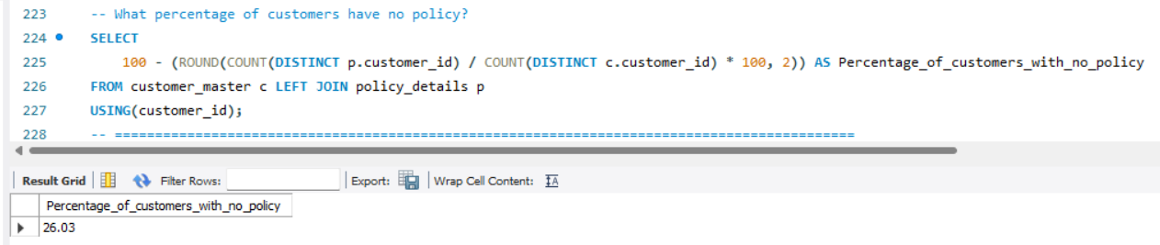
Approximately 26% of AegisLife customers never bought a policy in the dataset. This means that roughly 1 in every 4 customers do not buy any AegisLife policy. It highlights a potential customer conversion opportunity.

- Average conversion rate.
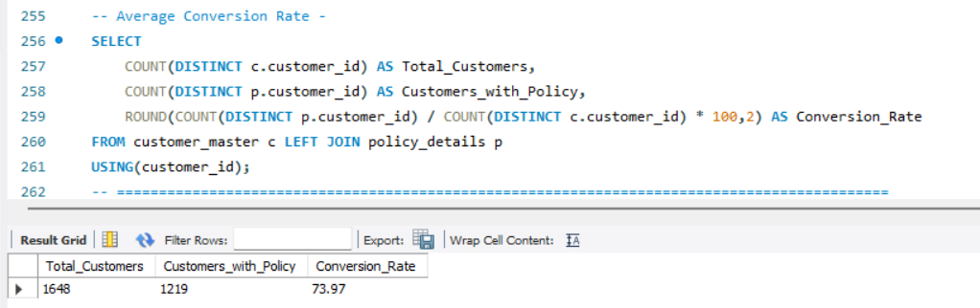
AegisLife has a customer-to-policy conversion rate of 74%. Out of 1,648 customers, 1,219 customers have purchased at least one policy, while 429 customers have no policy.

- How many policies does the average customer purchase?
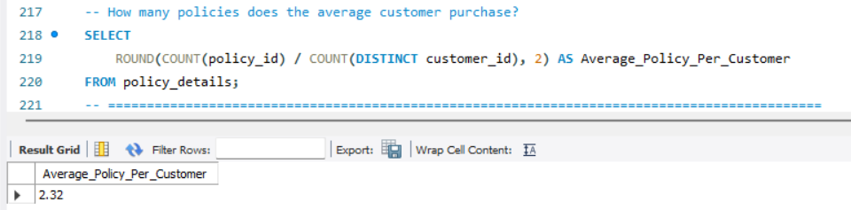
The average policy buying customer holds approximately 2.32 policies. This indicates that AegisLife’s customer base has a meaningful level of multi-policy ownership.

- Which customer segments have low conversion to policies?
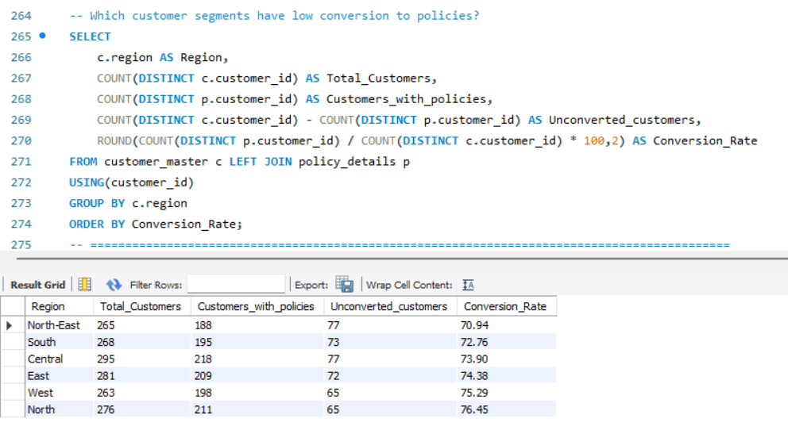
Policy conversion varies across regions, ranging from 70.94% to 76.45%. North-East has the lowest conversion rate of 70.94%, while North has the highest at 76.45%. South and central also have relatively lower conversion rates at 72.76% and 73.90% respectively.

- Policy distribution by product type.
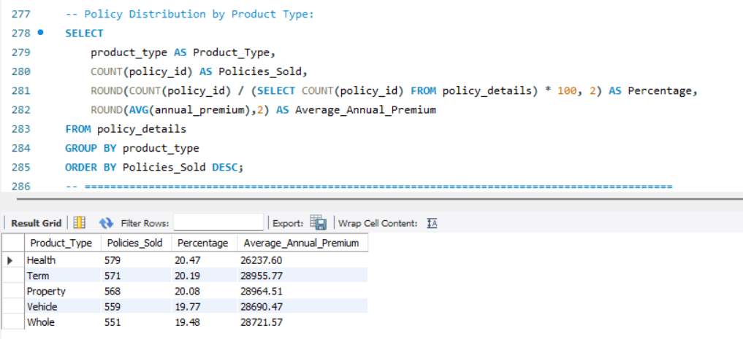
Policy distribution is relatively balanced across all five product categories, with each product accounting for approximately 19-10.5% of total policies.
However, the average annual premium differs more noticeably across products. Health has the lowest average annual premium, while Term has the highest at Rs.28,955.77/-.
- Policy distribution by age group.
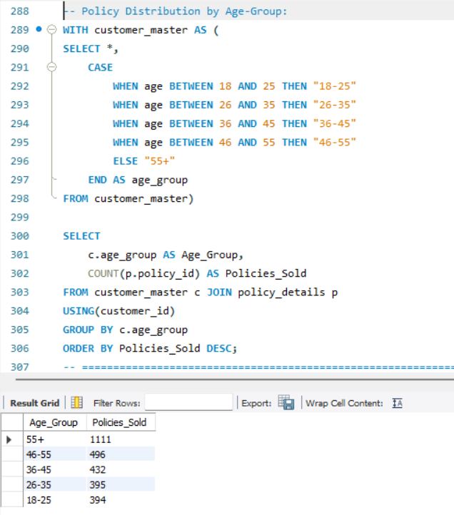
The 55+ age group accounts for the largest share of policies, with 1,111 policies, substantially higher than the other age groups.

- Policy distribution by occupation.
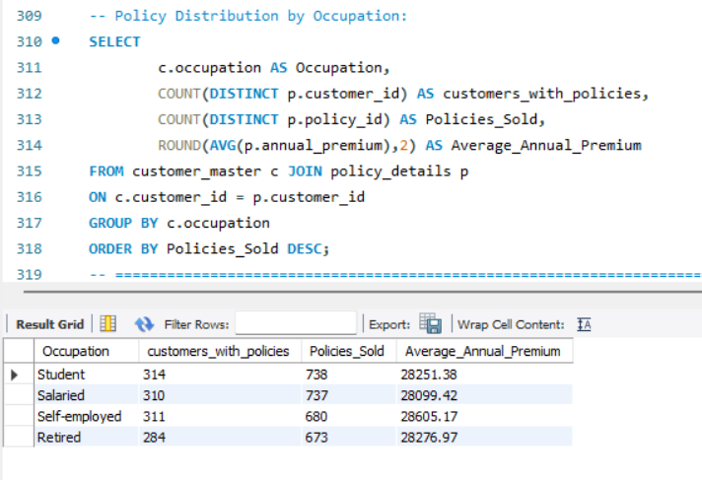
Students and salaried customers accounts for the highest number of policies, with 738 and 737 policies respectively. Self-employed customers hold 680 policies, while retired customers have the lowest policy volume at 673.

- Policy distribution by region.
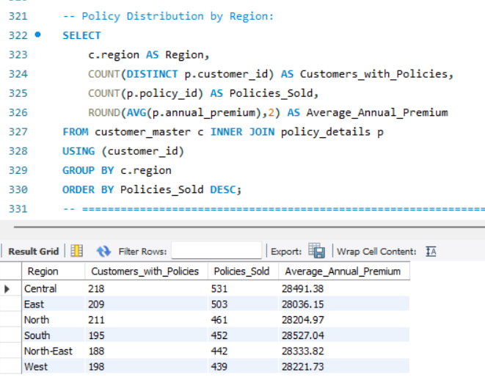
Policy volume varies across regions, with the Central region recording the highest number of policies at 531, followed by east with 503. West has the lowest policy volume at 439.

- What is the average annual premium per policy?
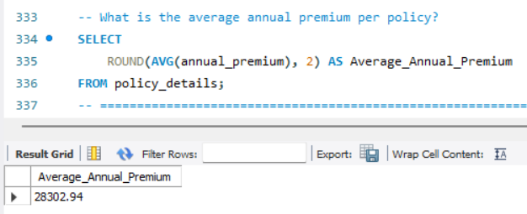
AegisLife’s average annual premium is Rs.28,302.94/- per policy.

- How has the policy selling trend changed year-over-year?
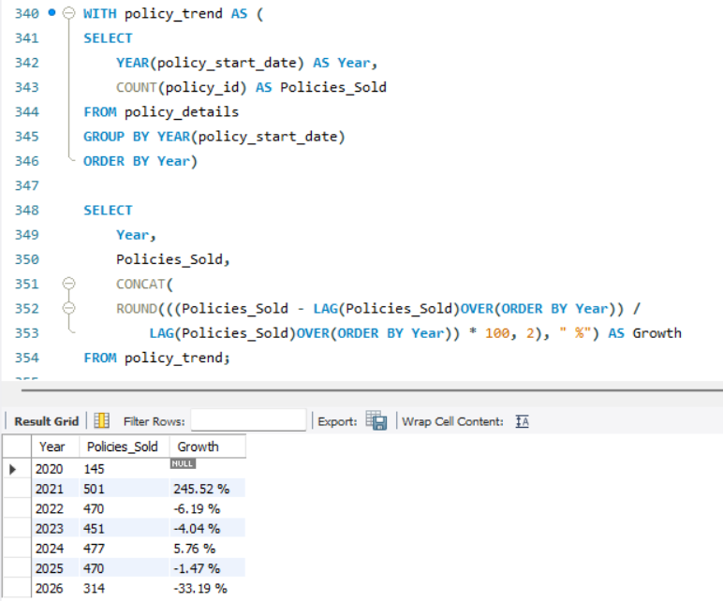
Policy sales increased sharply in 2021, rising from 145 policies in 2020 to 501 policies, representing a 245.5% year-over-year increase. After this significant increase, policy sales declined in 2022 and 2023 before recovering slightly in 2024. Sales remained relatively stable in 2025.

POLICY RETENTION / LAPSE ANALYSIS:
- Policy status analysis.
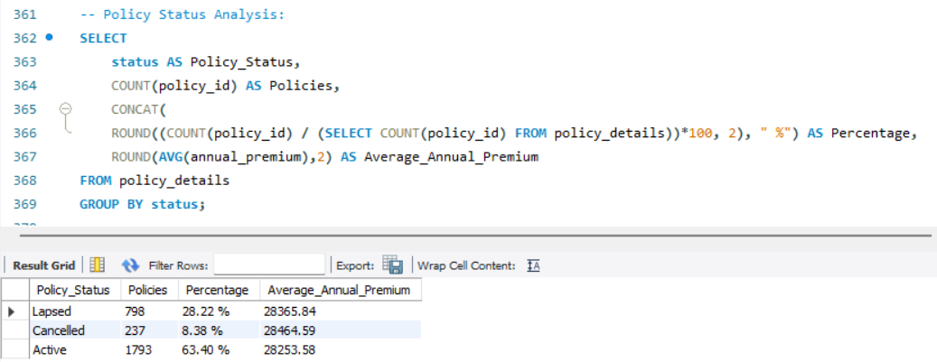
AegisLife has 1,793 active policies (active policies here in dataset means those policies that are not lapsed means all premiums are paid or there is no lapse noted in currently opened policies), representing 63.40% of the total policy. A further 798 policies (28.22%) are lapsed, while 237 policies (8.38%) have been cancelled.

- Which products have the highest lapse rate?
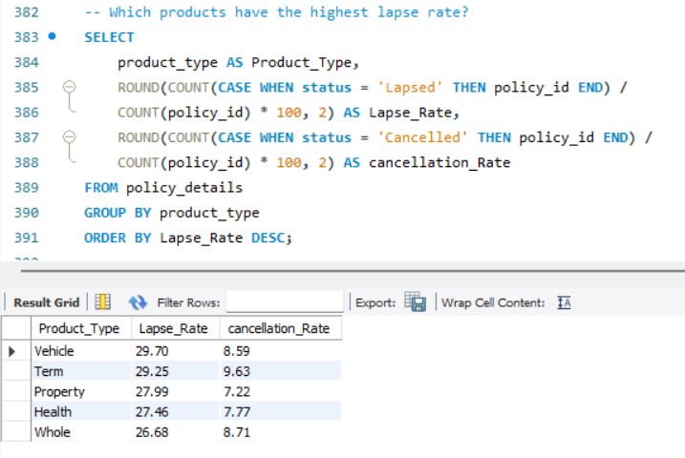
Lapse rate varies across AegisLife’s product portfolio, with Vehicle policies recording the highest lapse rate at 29.70% followed by Term policies at 29.25%. Whole policies have the lowest lapse rate at 26.68%.

- Which regions have the highest lapse rate?
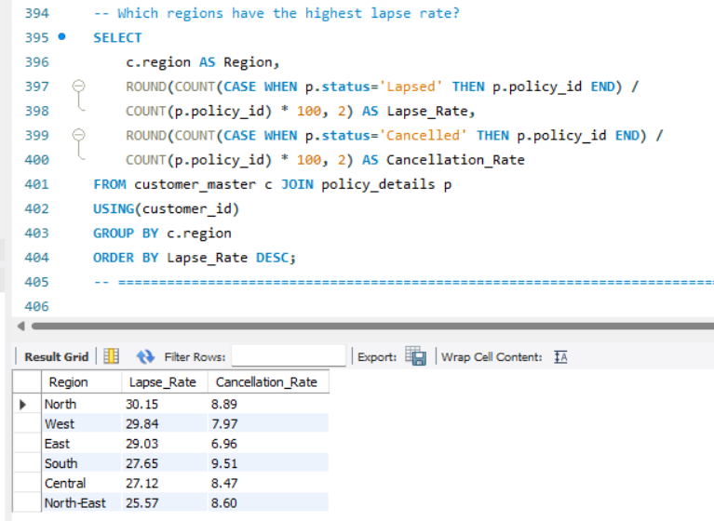
Lapse rates vary across regions, ranging from 25.57% to 30.15%. the North region has the highest lapse rate at 30.15%, followed by West at 29,84% and East at 29.03%. North-East has the lowest lapse rate at 25.57%.

- Which occupations have the highest lapse rate?
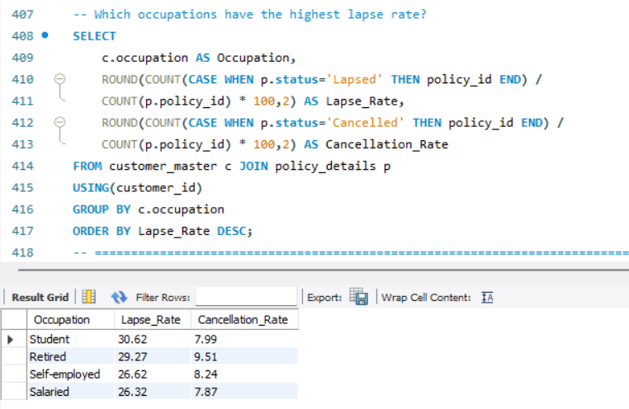
Lapse rate varies across occupational groups. Students have the highest policy lapse rate at 30.62%, followed by retired customers at 29.27%. Self-employed and salaried customers have lower lapse rates of 26.62% and 26.32% respectively.

- Are high-risk customers more likely to lapse?
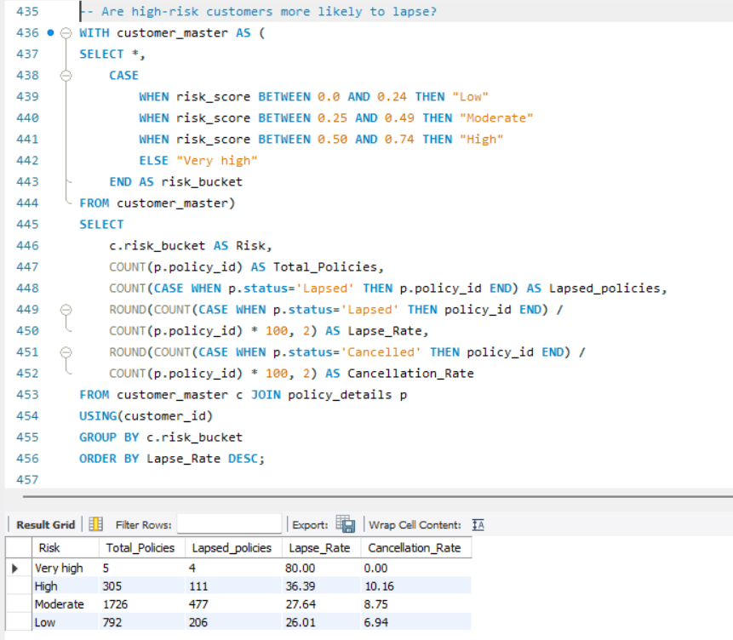
The Very High-risk category shows a lapse rate of 80%; this segment contains only four policies. Among the larger segment, High-risk policies have a substantially higher lapse rate (36.39%) than Moderate (27.64%) and Low-risk policies (26.01%).

CLAIM ANALYSIS:
- How many claims are being filed and what is the fraud ratio?
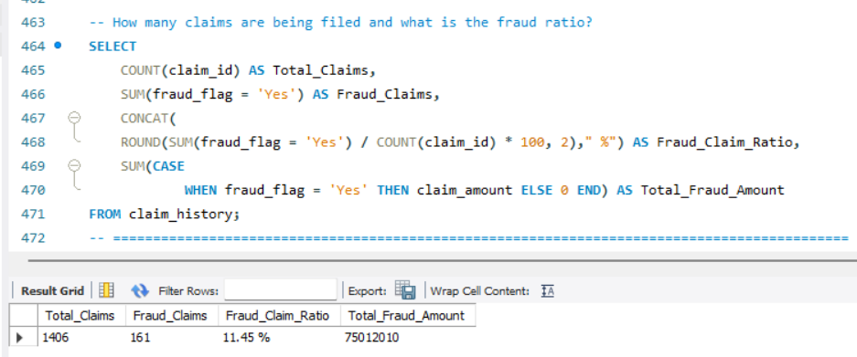
AegisLife recorded 1,406 claims, of which 161 were flagged as fraudulent, resulting in a fraud claim ratio of 11.45%. This means that roughly 1 in every 9 claims in the dataset was flagged as fraudulent. The total amount associated with fraud-flagged claims is approximately Rs.7.5 crore.

- What is the claim frequency per policy?
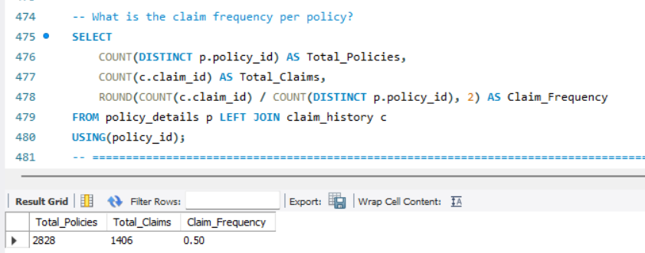
AegisLife recorded 1,406 claims across 2,828 policies, resulting in an average claim frequency of 0.5 claims per policy, equivalent to about 50 claims per 100 policies.

- Which products have the highest claim frequency?
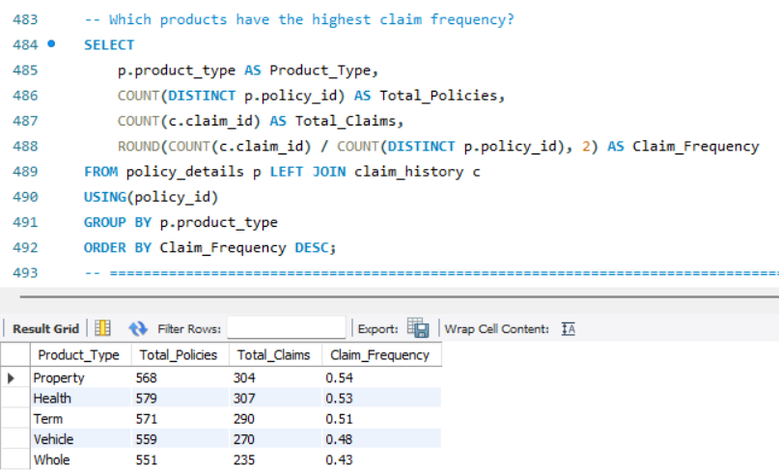
Claim frequency varies across product types. Property policies have the highest claim frequency of 0.54 claims per policy, followed closely by Health at 0.53 and Term at 0.51. Vehicle and Whole policies have claim frequencies of 0.48 and 0.43 respectively.

- Does smoking status correlate with claim frequency?
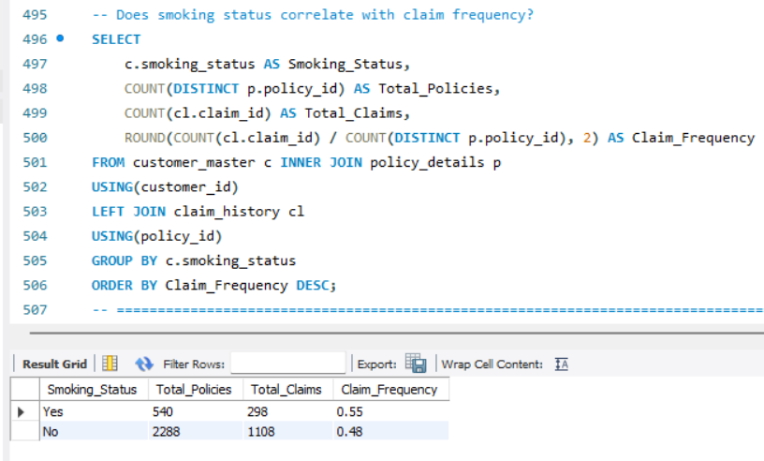
Smokers have a higher observed claim frequency than non-smokers. The smoking group recorded 0.55 claims per policy, or approximately 14.6% higher claim frequency for smokers relative to non-smokers.
- Does pre-existing illness correlate with claim frequency?
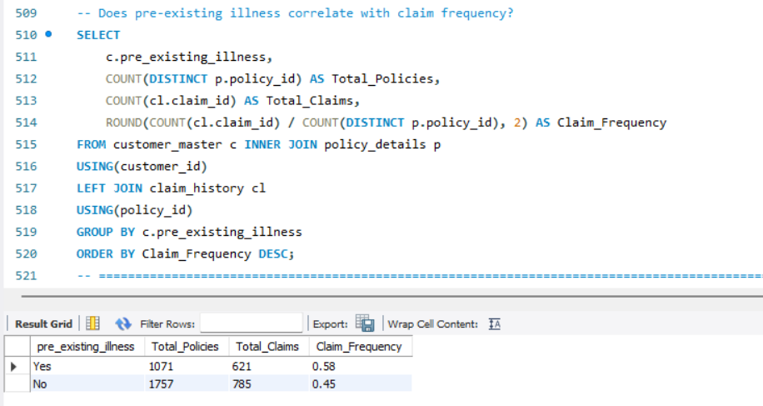
Customers with pre-existing illnesses recorded a higher observed claim frequency of 0.58 claims per policy, compared with 0.45 claims per policy among customers without pre-existing illnesses. This represents approximately 28.9% higher claim frequency relative to the non-illness group.

- How has claim volume change over time?
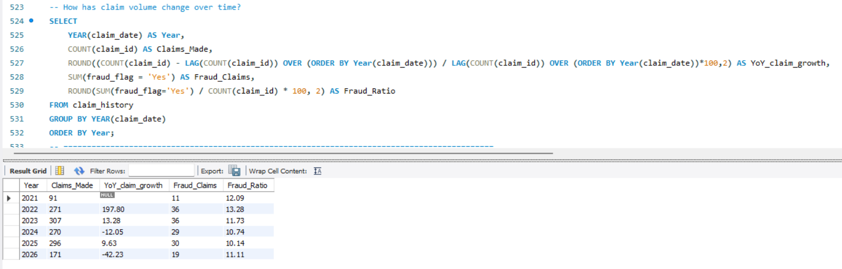
Claim volume increased substantially between 2021 and 2023, rising from 91 claims in 2021 to 307 claims in 2023. The largest year-over-year increase occurred in 2022, when claims increased by 197.8%. Claim volume then declined by 12.5% in 2024 before recovering by 9.63% in 2025.
- Claim Analysis by claim_type.
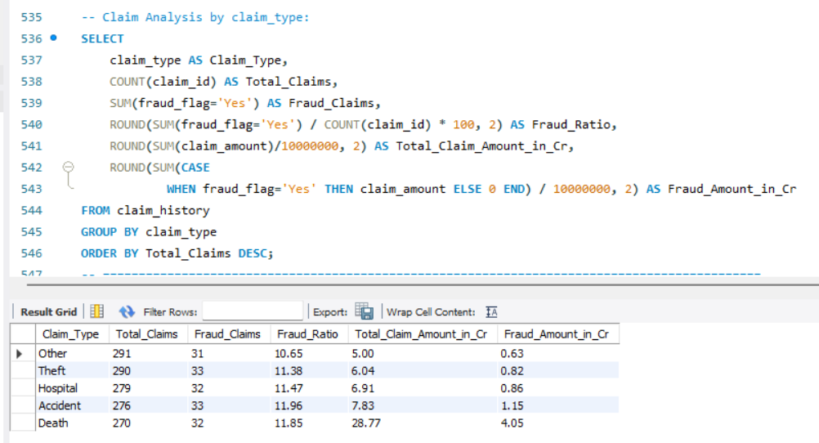
Claim volumes are relatively similar across claim types, ranging from 270 to 291 claims. However, the financial impact varies significantly. Death claims have the highest total claim amount at approximately Rs.28.77 crore, despite having the lowest claim volume. Accident claims follow with Rs.7.83 crore. This indicates that claim frequency and financial severity vary significantly by claim type.

- Does higher customer risk translate into higher claim frequency?
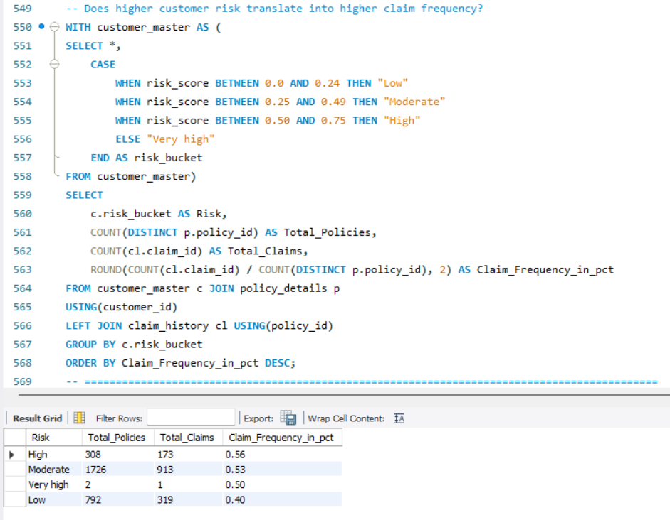
Higher-risk policyholders exhibit higher observed claim frequency in the dataset. Claim frequency increases from 0.40 claims per policy among low-risk customers to 0.53 among moderate-risk and 0.53 among high-risk customers. This indicates a positive association between risk category and claim frequency.

- Claim Status Analysis.
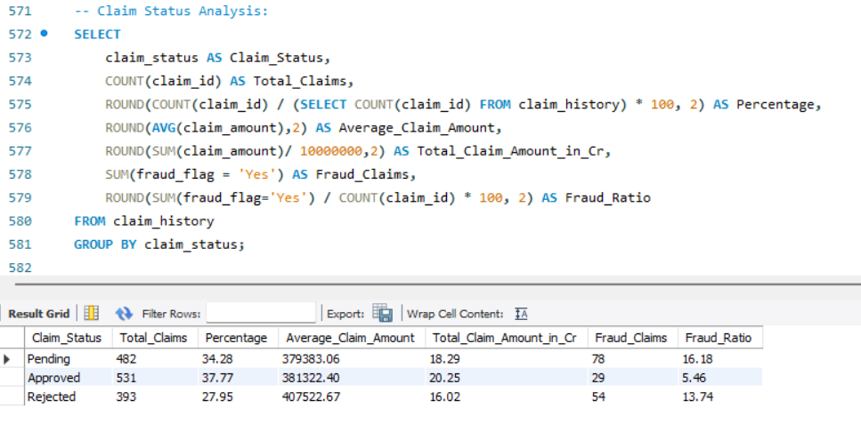
Approved claims represent the largest share of the portfolio at 37.77% and account for Rs.20.25 crore in total claim value. Rejected claims have the highest average claim amount of approximately Rs.4.07 lakh per claim. Pending claims have the highest fraud-flag rate at 16.18% and the largest number of frauds flagged claims (78).

FRAUD ANALYSIS:
- What percentage of claims are fraudulent and what is the total value of fraudulent claims?
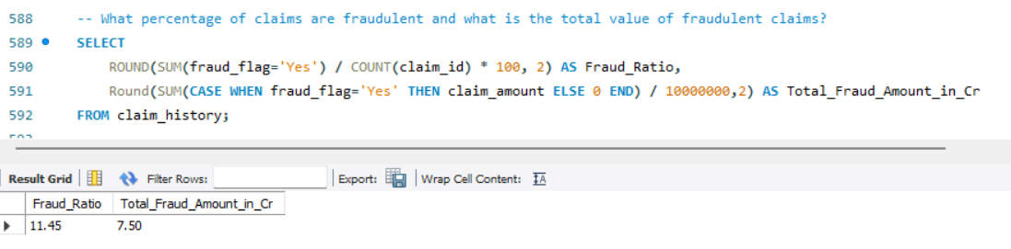
Of the total claims in the portfolio, 11.45% were flagged for potential fraud, representing approximately Rs.7.50 crore in associated claim amounts. This indicates that fraud-flagged claims account for a meaningful portion of the claim’s portfolio.
- Which product has the highest fraud-ratio?
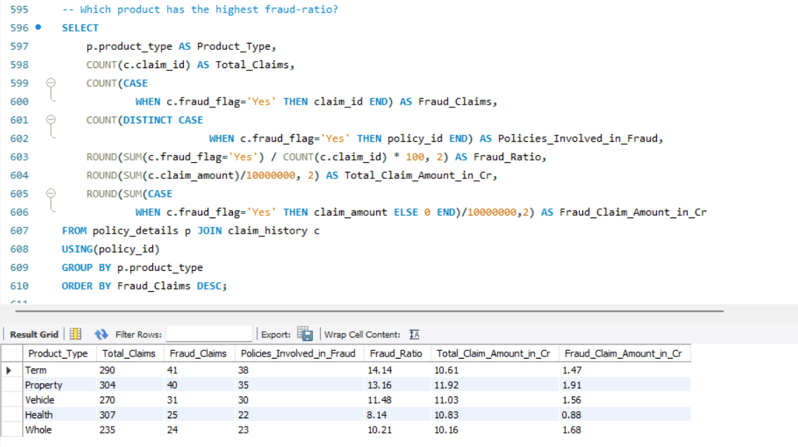
Term policies have the highest fraud-flag rate of 14.14%, while Property policies have the highest fraud-related financial exposure at Rs.1.91 crore.

- Of all the money AegisLife actually approved for claims, what percentage was attributable to fraudulent claims?
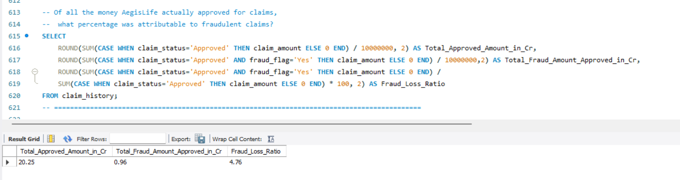
AegisLife approved claims worth Rs.20.25 crore, of which approximately Rs. 96 lakh was associated with fraud claims. This represents a fraud loss ratio of 4.76%.

- Which sales agents have policies that are subsequently associated with the highest number of fraud-flagged claims?
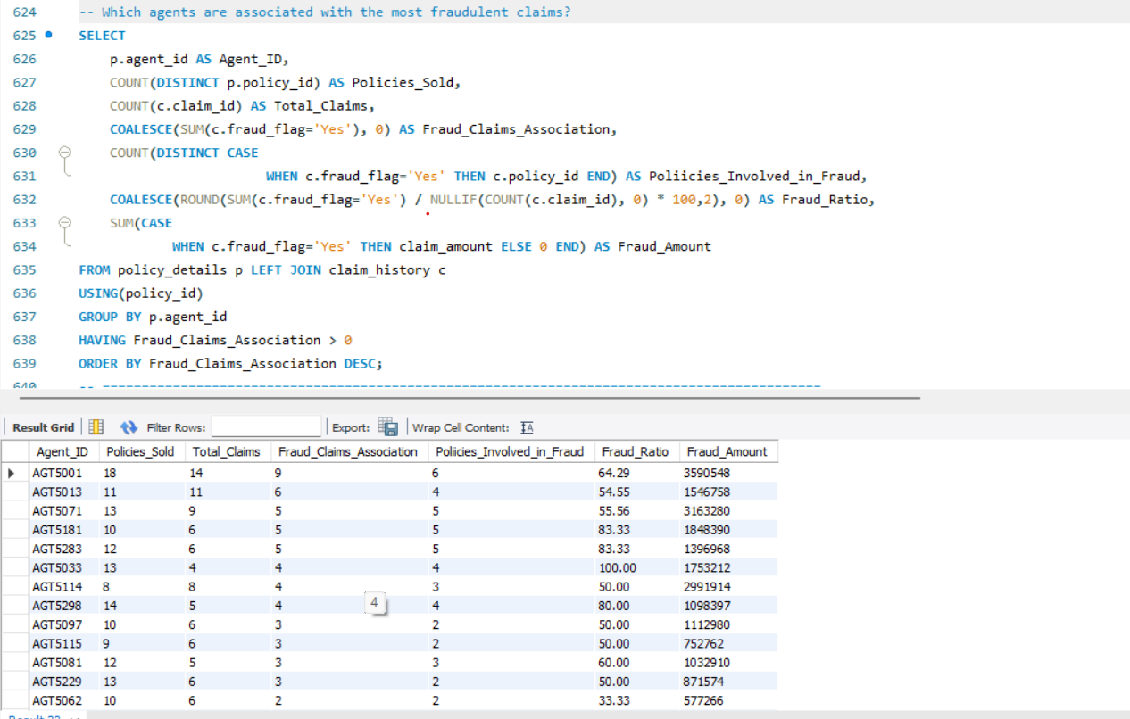
Sales agents shows considerable variation in the number and value of fraud-flagged claims associated with the policies they sold. AGT5001 recorded the highest number of associated fraud-flagged claims (9). This query output represents the list of agents that have any fraud association.

- Which customers have fraudulent claims?
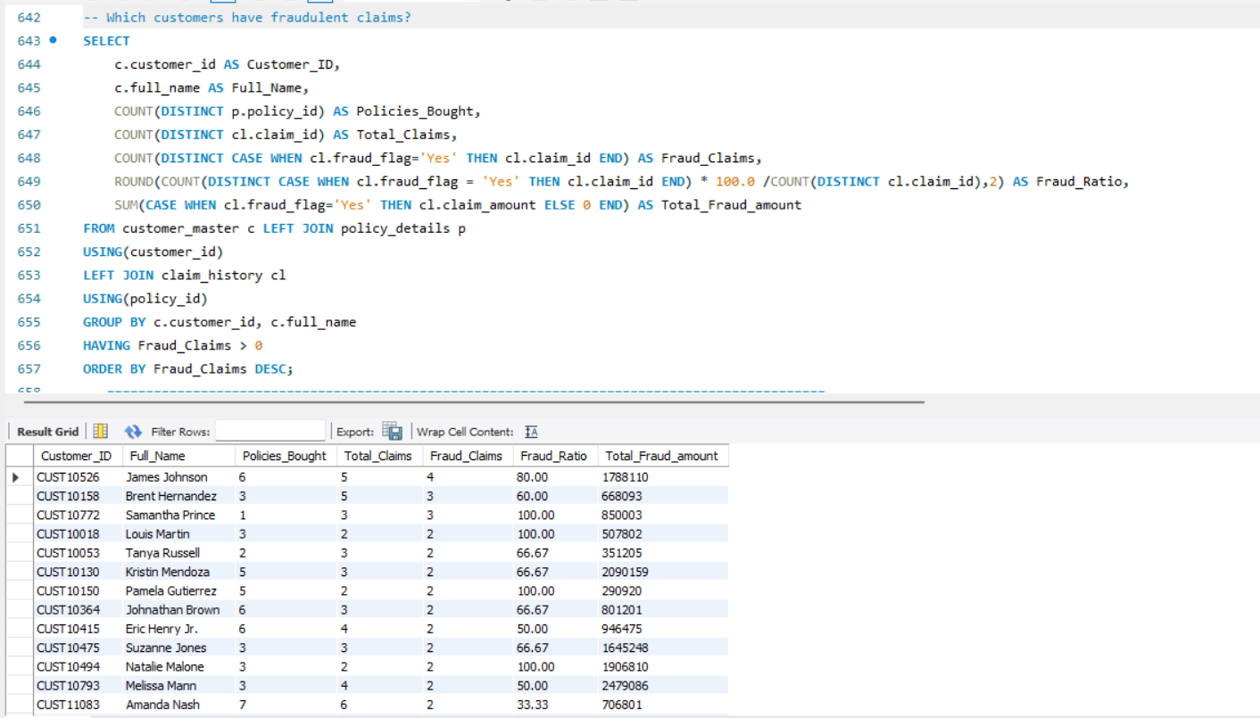
Customer-level fraud analysis identified customers whose claims were flagged for potential fraud and quantified the associated financial exposure. CUST10526 recorded the highest number of frauds flagged claims.

- Are fraudulent claims concentrated among specific customer risk segments?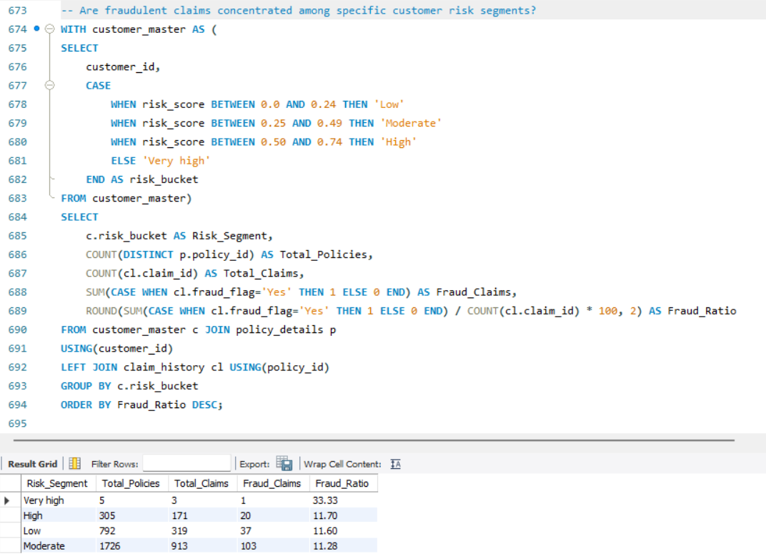
Fraud-flagged claims are not strongly concentrated within the risk customer segment.

AGENT PERFORMANCE:
- Agent Performance Actual Vs Recorded: Checking for discrepancy in data if any:
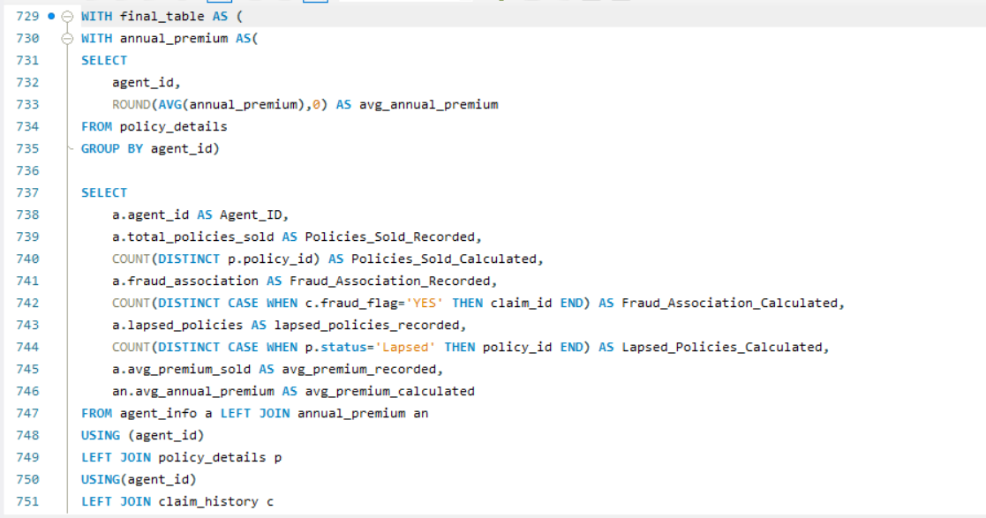
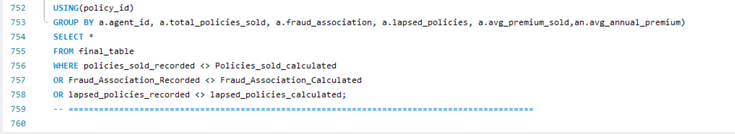
Agent-level reconciliation found no discrepancies between recorded and calculated policy sales, fraud associations, lapsed policies, and average premiums. This indicates that the agent summary data is consistent with the underlying transactional records.
- Which agents sell the most policies?
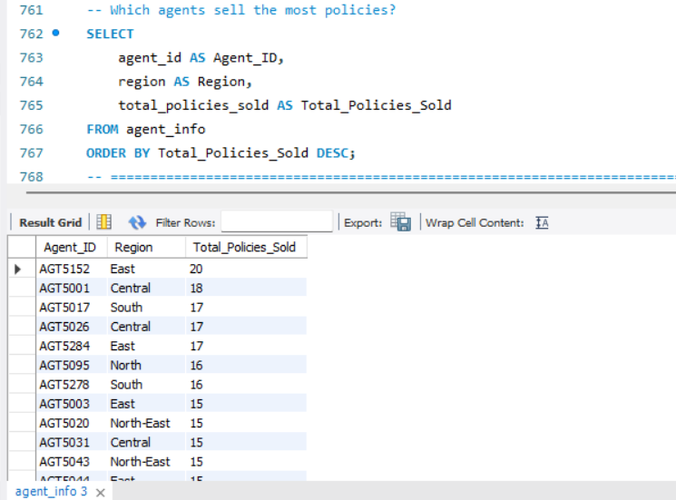
Agent-level sales analysis shows that AGT5152 from the East region recorded the highest policy sales with 20 policies, followed by AGT5001 from central with 18 policies. This query gives the list of number of policies sold by agents.

- Which agents have the highest claim approval rate?
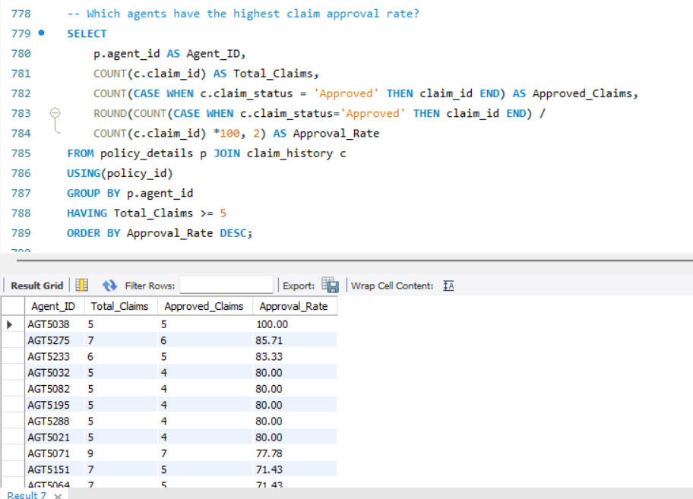
Claim approval analysis by sales agent, restricted to agents with at least five associated claims, showed variation in observed approval rates. AGT5038 recorded the highest approval rate at 100%, with all five associated claims approved. AGT5275 and AGT5233 followed at 85.71% and 83.33% respectively.

CUSTOMER SATISFACTION:
- What is the overall customer satisfaction score?
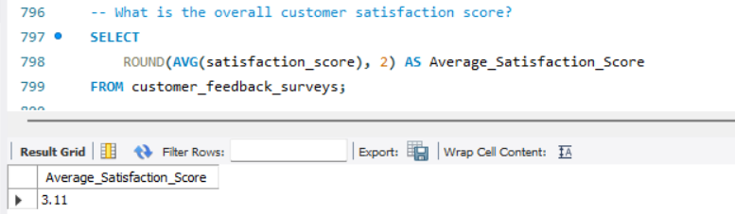
The overall customer satisfaction score is 3.11 out of 5, indicating a moderate level of customer satisfaction. It suggests that there is room to improve the customer experience.

- Does satisfaction score differ by region?
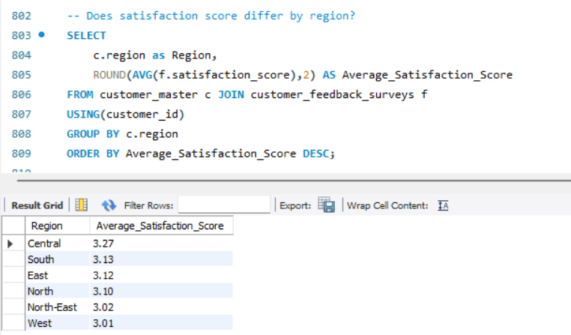
Regional satisfaction analysis shows relatively consistent customer experience across six regions.
- Does satisfaction score differ by age-group?
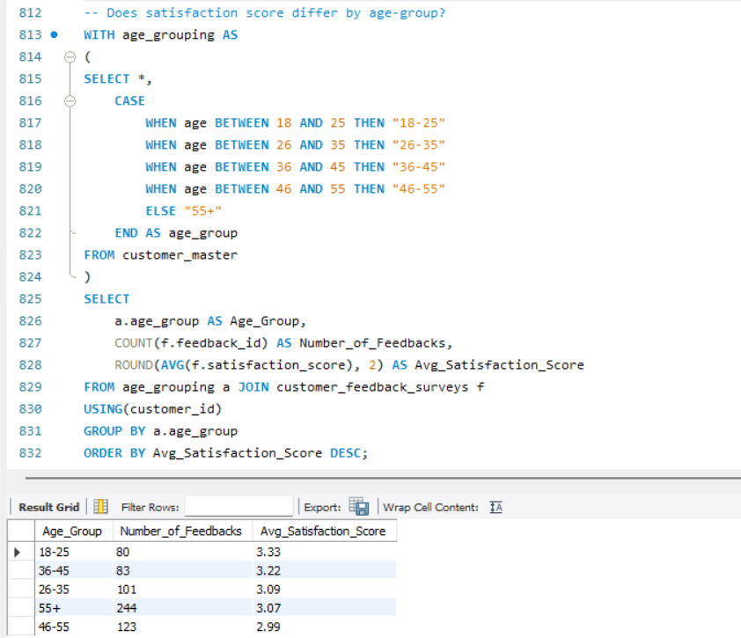
Age-group analysis shows moderate variation in customer satisfaction. Customer aged 18-25 reported the highest average satisfaction score at 3.33, while customers aged 46-55 recorded the lowest at 2.99.

- Does contacting an agent has an impact on satisfaction?
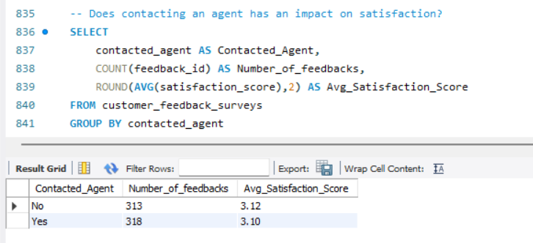
Customer satisfaction was compared between customers who contacted an agent and those who did not. This analysis suggests no observable difference in satisfaction between the two groups.

- Which feedback categories have the highest/lowest satisfaction?
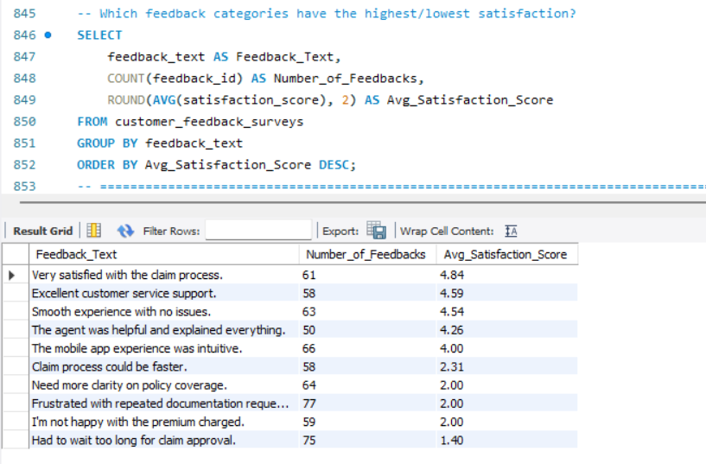
Customers appears highly satisfied when the claim/service experience is smooth and support is effective, while delays in claim approval, repeated documentation requirements, policy coverage clarity, and premium dissatisfaction are associated with substantially lower satisfaction scores.

- Are customers who filed claims less satisfied?
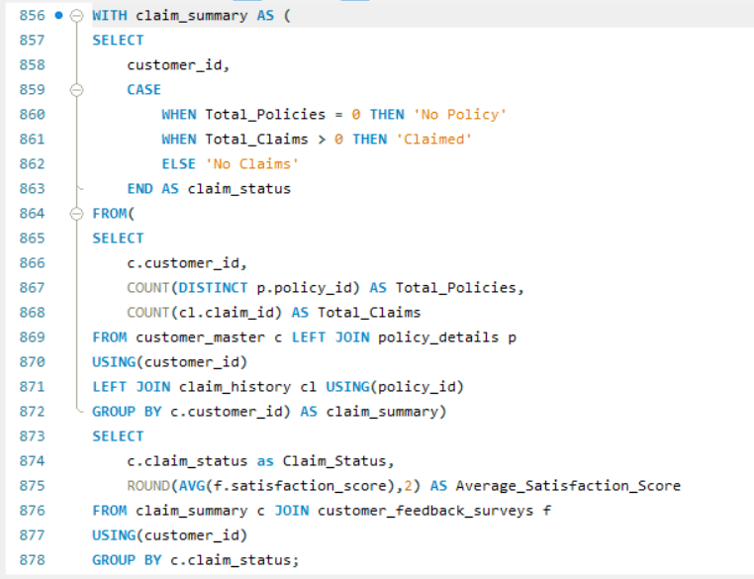
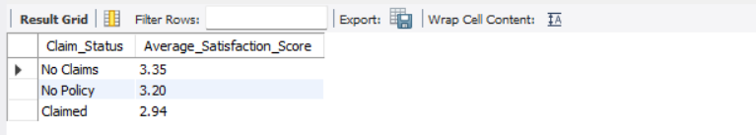
Customers with claims reported an average satisfaction score of 2.94, compared with 3.35 among customers who had not filed claims. This 0.41 point difference suggests that the claim experience is associated with lower customer satisfaction.

